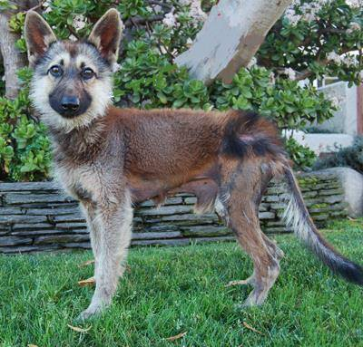Pituitary Dwarfism in the German Shepherd Dog

by
Stephen Webb BSc (Hons), BA, BSc, MSc

UK Ambassador - Saartje Foundation for Pituitary Dwarfism in Dogs

Pituitary Dwarfism - a bigger problem than expected

Pituitary dwarfism is a rapidly increasing problem in the German Shepherd Dog and is thought to have originated as a spontaneous mutation (University of Utrecht) sometime during the 1940's, when the GSD was seriously depleted during and after World War 2. At this point there was a period of intensive inbreeding and this recessive allele occurred and was quickly spread during this bottleneck within the breed's history. Despite much research that has been done, including the use of Max von Stephanitz's own notes, no recorded reference of pituitary dwarfism prior to this period could be found. It cannot however be totally discounted that this was a very rare allele that was present in the founders at the formation of the breed and has increased within the population through genetic drift - unlikely, but possible.

A small number of people over the years have attempted to highlight the problem - most notably Fred Lanting and John Walker in the 1980s and 90s respectively; at this time, however, they had relatively little scientific information to go on other than their own experiences of dwarfs. Things are much different now, with clear scientific evidence of the very harmful genetic effects to the German Shepherd Dog population from this defective recessive gene.
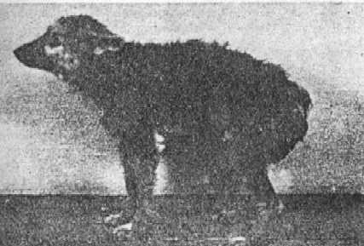
The first documented case in Germany was around 1951 resulting in the Moch & Haase (1953) paper. This was a thorough investigation at the University of Hannover of a GSD dwarf around 11 months old, 34 cm at the shoulder, weighing 6.1kg, and the paper included the first published photograph of a pituitary dwarf - shown here:

But what is Pituitary Dwarfism, why the concern?

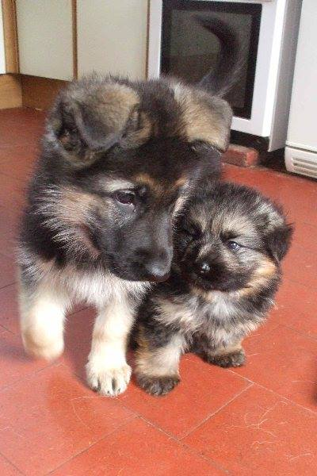
Pituitary dwarfism is the effect of an autosomal recessive inherited disorder of the pituitary gland caused by a mutation of the LHX3 gene on Chromosome 9 (deleted base pair sequence GCGCCCC at Intron 5) and at present encountered in only the German Shepherd Dog and its derivatives where 20% (source: University of Utrecht) are now estimated to carry the faulty gene. The pituitary is a hormone-producing endocrine gland at the base of the brain. This pea-sized gland is composed of the anterior lobe and the posterior lobe. The anterior pituitary synthesizes many of the essential hormones which are then secreted for numerous body functions such as growth, reproduction, lactation and metabolism.

Hormones secreted by the pituitary gland from the anterior lobe are: growth hormone (GH) which is essential for growth, Thyroid Stimulating Hormone (TSH) which regulates thyroid function, Prolactin (PRL) which is essential for lactation, Follicle Stimulating Hormone (FSH) for hair growth, Luteinizing Hormone (LH) which is essential for ovulation in female dogs and sperm production in male dogs, and Adrenocorticotroph Hormone (ACTH) which stimulates the adrenal cortex.
'Hobbit' and normal litter mate at age 8 weeks

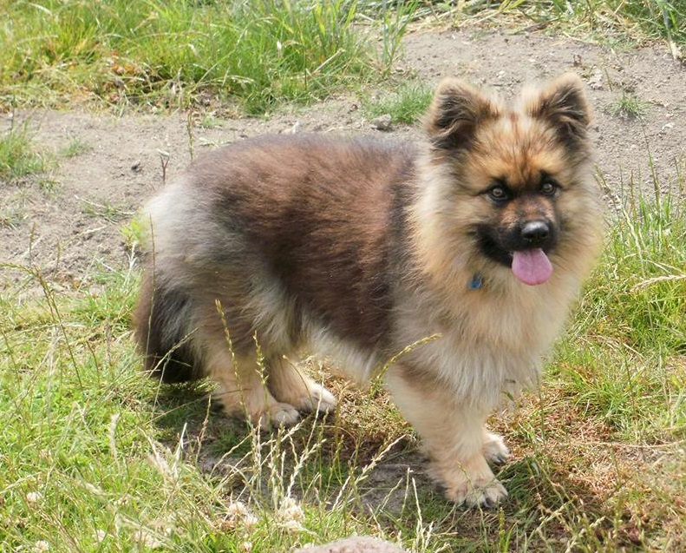
The clinical symptoms of dwarf dogs are not limited to their visible appearance, and any defect in the development of the pituitary gland creates enormous problems for the dog - the most obvious visible example of hormone deficiency is the small proportionate stature and the associated hair loss, but there are also many hidden problems. They suffer from a whole range of detrimental
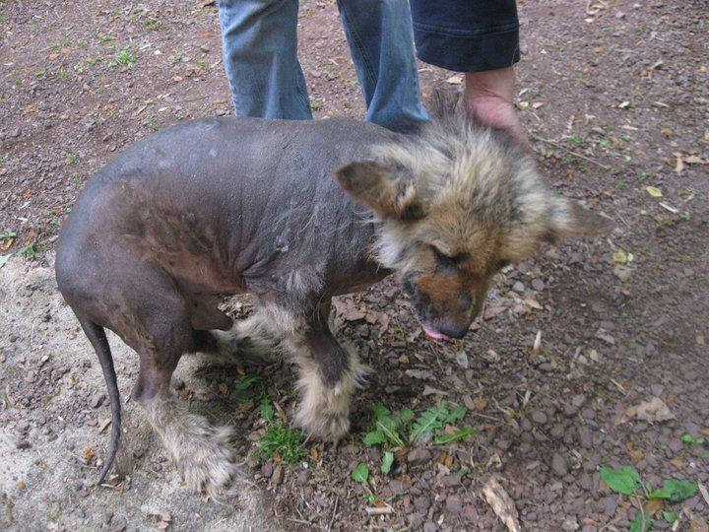
hormonal conditions - particularly from under development of the liver and kidneys causing chronic renal failure, cardiovascular problems such as Patent Ductus Arteriosus (PDA) and also, for many, a range of neurological conditions.
‘Hobbit’ aged 2 years - Treatment with proligestone from age 8 months has made great improvements to coat and appearance, but Hobbit still has many internal problems

The deficiency of Thyroid Stimulating Hormone (TSH) results in an under-active thyroid gland (hypothyroidism) causing many animals to be slow, dull and - with some - aggressive tendencies due to the lack of TSH. Additionally the reduced level of gonadotrophins may result in failure of one or both testes to move or "descend" into the scrotum (cryptorchidism) in male dwarfs, while female dwarfs do go into heat more often and for longer than normal but they do not ovulate. Females are particularly prone to urinary tract infections.

Without proper treatment, the long term survival rate is generally poor. Many dwarfs will not live to more than 4 to 5 years of age, based on university records. However, there are a significant number of dogs that do live longer, even untreated. The Saartje Foundation has reported examples up to 14 years of age, probably because in some cases the pituitary gland still produces enough of the required hormones to survive.

Treatment with Porcine Growth Hormone can be used on these dogs, but it will not increase the size of a pituitary dwarf. What it will do is aid the development of the renal system, and will also help them to retain their coats. However, Porcine Growth Hormone is also very difficult to obtain and available only through restricted research use, and therefore not given to many.

Dogs that are carriers of the recessive gene do not have any visible symptoms and look exactly the same as the dogs that are not carriers - and this is the problem. The birth of an affected dog means that BOTH parents are carriers, each with a single copy of the gene - and, of course, when two carriers of a recessive gene are mated, on average 50% of their progeny will be carriers, 25%

clear and 25% will be affected as pituitary dwarfs. The two genotypes shown below are; Normal (AA) and Carrier (Aa) and produce on average the following distribution of offspring.

The affected (a a) are discounted at present as most dwarf dogs are infertile - but not all: some males have been found to have active sperm, but no research has yet been done to test whether or not the sperm are in fact viable.

- - - - - - - - - - - - - - - - - - - - - - - - - - - - - - - - - - - - - - - - - - - - - - - - - - - - - - - - - - - - - - - - - - - - - - - - - - - - - -
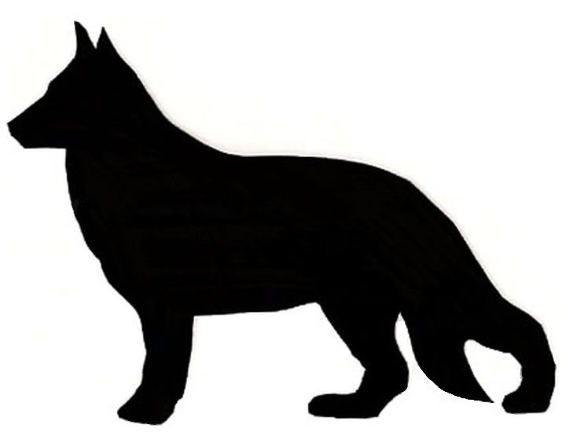
Normal X Normal = 100% Normal

Normal X Carrier = 50% Normal 50% Carrier

Carrier X Carrier = 25% Clear 50% Carrier 25% Affected

Dwarf dogs to date have not been found to be capable of breeding, as already stated, and therefore are automatically excluded. Even though a small minority are found to be fertile the physical stature of a female dwarf makes it exceptionally unlikely that she will carry a litter of pups to full term, as the developing dwarf pups in the womb are virtually the same size as normal GSDs; the uterus, interestingly has been found in many cases to be that of a full size normal dog.

Reports of a clear sire to a dwarf dam mating have resulted in the death of both dam and pups.

Affected X Affected = No progeny have been reported
Normal X Affected = Unconfirmed reports of death of dam during pregnancy
Affected X Normal = No progeny have been reported

In terms of size and appearance, many dwarfs can in fact be very difficult to tell apart from their litter mates at birth. There have been many instances where the largest pup born has turned out to be the dwarf - which is contrary to what many people believe, so it is not surprising that identification mistakes often occur.

Arguably, on a day-to-day basis the most difficult thing to manage with these dogs are the skin issues. When a dog loses its puppy coat, starting usually on the underside, the skin can become squamous (scaly) and hyper-pigmented, that is the skin becomes gradually much darker in colour than normal (blackened), and due to their

greatly lowered immunity dwarfs can be very prone to deep bacterial skin infections which are then very difficult to eliminate. Dermatological conditions are many and extend to a soft woolly retained puppy coat, lack of guard hairs, bilateral symmetrical baldness on trunk, neck and proximal extremities, hyper-pigmentation of the skin, thin fragile skin, wrinkles, comedones, papules, pyoderma, seborrhea sicca (dry flaky skin) or seborrhea oleosa (oily flaky skin). Alopecia is caused by the endocrine or hormonal abnormalities, and is managed by treating the underlying disorders. For example, alopecia associated with hyperthyroidism or pituitary dwarfism can be treated with lifelong hormone replacement medication. Spaying and neutering can also have a positive outcome for hair loss caused by certain other hormonal imbalances; many dwarf owners have seen regrowth after this procedure, but not all. Dry flaky skin & itching is perhaps the more common complaint which can become quite a distressing problem for many dogs. The drug Atopica, an immunosuppressant, is usually prescribed for long term use to combat itchiness, rather than steroids which for these dogs is the lesser of two evils as both cause long term damage.

A pituitary deficiency can lead to a deficiency in the metabolism of essential fatty acids and the correct formation of the skin barrier. Any deficiency of oils here can lead to increased trans-epidermal water loss, which in turn causes the problem itchy dry skin seen by many.

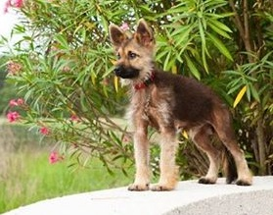These dogs can also have dental problems, and a significant proportion tend to have a slightly over-shot jaw, which adds to their fox-like appearance. The milk teeth can be delayed and retained much longer as the adult

teeth come through, sometimes giving rise to veterinary intervention to remove them. My own dog had no issues with his teeth, which were fully formed and complete with a perfect scissor bite that any normal GSD would have been proud of, but he was the exception.

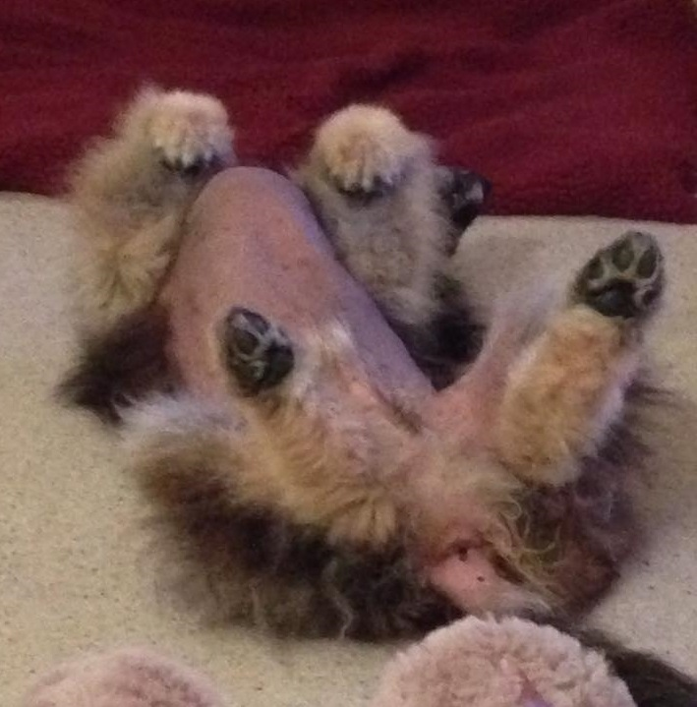
Although the physical features of pituitary dwarfism may seem obvious, the final diagnosis should be combined with 'pituitary stimulation tests'. These tests can detect a deficiency of GH, TSH, FSH, LH and Prolactin where treatment can then be tailored to the correct dosage to meet an individual's needs. The use of porcine growth hormone (Reporcin) should ideally be given before 3 months of age and continued until the growth plate's close - which is actually delayed in a dwarf dog and can be well over 18 months up to four years in some cases, much longer than normal GSDs' growth plate closure. The problem here is that there is much misinformation about - even within the veterinary profession - regarding growth hormones and their use in the treatment of Pituitary Dwarfism, which has occurred mistakenly from the use of trials with human growth hormone. Many vets who are able to obtain it will only give GH for 6 weeks, which is not nearly enough, but this is what the medical literature states. This has arisen because when human GH was first used in trials it was rejected by the dogs - usually after a period of 6 weeks - and it was assumed and wrongly recorded that other forms of GH would also be rejected after this period and therefore PGH is stopped much too early. If canine growth hormone was available, then this would be used to treat dwarfs - but it is not, so animals are treated with porcine GH which makes a very good alternative.

Secondary Hypothyroidism

As a consequence of pituitary dwarfism, secondary hypothyroidism is seen in these dogs and this presents even more problems for them, including weight gain as they age, and hair loss over the whole of the trunk with the exception of the head and legs, which is due to hypothyroidism giving the classical visual symptoms of hypopituitary dwarfism. Hormones affect almost every organ in the body and the lack of them can play an enormous role in the temperaments of these dogs; there is a wide variety from dull and lethargic to an apparent normally behaving dog. Most of the veterinary literature available states - incorrectly I might add - that dwarf dogs tend to be dull and lethargic due to low levels of TSH. In reality this is not entirely true - a large proportion are just as active & alert as a normal dog and also just as trainable. There are quite a range of symptoms associated with hypothyroidism but the differences between dogs can be quite large.

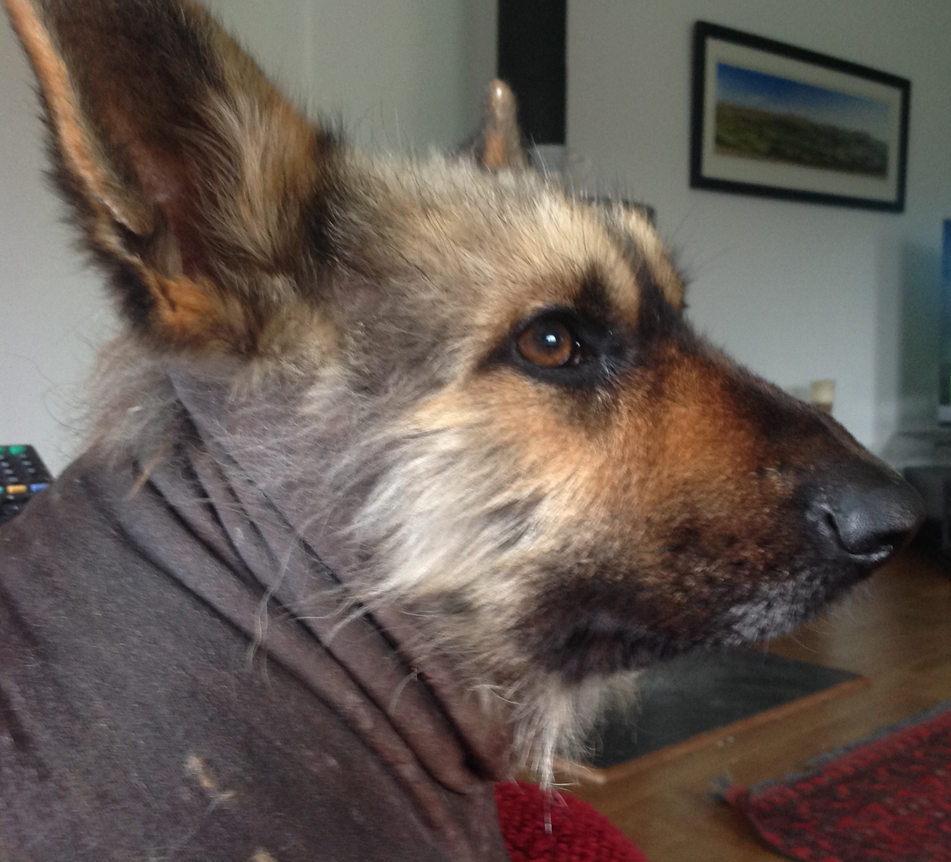
It is also well known that hypothyroidism is one of the most common medical causes of aggression or abnormal behaviour in dogs, and dwarf dogs are no exception - some can become aggressive over what would be considered rather trivial issues in normal dogs - for example, the touching of certain parts of their body.

This could be considered a behavioural issue in many dogs, but the very low thyroid levels tend to affect mood and sometimes it is difficult to tell the difference between aggressive behaviour due to thyroid levels and socialisation or training issues. Thyroid replacement therapy has worked well in many cases to relieve aggression in dogs with hypothyroidism. While having a pronounced affect on some, the hormonal imbalance does not affect all dogs in this way. My own dog and many others, despite being untreated for dwarfism, have not shown any problems with regard to temperaments despite being predisposed to it by virtue of low levels of TSH. To determine the thyroid hormones present, a series of tests need to be performed, as a single test will not give a complete picture of their hormonal replacement requirements. Once the levels have been determined, the treatment in tablet form is simple and quite successful using L-thyroxine.

Post mortem findings at the University of Utrecht carried out on pituitary dwarfs have included; Pituitary Cysts, Pituitary Atrophy, Hypoplasia of the Thyroid Gland, Patent Ductus Arteriosus (PDA) and also under development of the Renal System. Neurological complaints were also being seen, and in some cases were causing great concern. Reports of sudden unexplained deaths were investigated by the University of Utrecht. After conducting a number of post mortems, the cause was found to be incomplete ossification of the first and second cervical vertebrae, with atlanto-axial subluxation and flattening of the cerebellum.

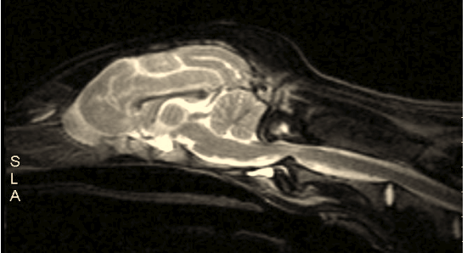The following MRI scan of 'Faith', an 8 month old dwarf,
shows the spinal cord being pinched due to this condition: Subluxation may at least be treated with rest and

treatment and, if necessary, corticosteroids or surgical intervention, whereupon the joint is stabilised.

Pituitary dwarfism has now become a global issue, with dwarf dogs being reported to us at the Saartje Foundation every week, increasingly from North America and Australia. It seems that no country is immune from this condition and such is the extent of PD that isolated populations are now quite possibly unlikely to exist - certainly in the "show" lines. The following data is presented across all GSD lines such as "show" and "working" lines through to pet lines, including white shepherds (Bergers Blanc Suisse), in both Europe and the USA.

Managing this recessive gene would however be quite different from most undesirable genes, in that those affected are already lost to the gene pool so there is no conflict of interest in their use for breeding programs. It's all about managing the carriers. What is known is that, if left to continue, this defect will become a breed trait and hence impossible to eliminate without irreparable damage to the genetic diversity of the GSD. The gene could have been dealt with much sooner. I fear that all that can be done now is, at best, to reduce its occurrence - but even this would take many generations to complete, assuming there is actually the will to do so. As it is, the PD gene will only increase relentlessly over time.

The graph below shows where we are now - 30% carriers and 4% affected, taken from a random sample in Europe by the University of Utrecht - and also where we are projected to be heading:

50
40
30
20
10
0
% PD Affected
% PD Carriers
0
5
10
15
20
25
30% Carriers 4% Affected - 2017

Year | PD Gene frequency  freq.(A)=p freq.(a)=q | PD Genotype frequency  (A A)=p² (A a)=2pq (a a)=q²
1950  1982  2010  2016 | 0.99 0.01  0.95 0.05  0.90 0.10  0.81 0.19 | 0.9801 0.0198 0.0001  0.9025 0.0950 0.0025  0.8100 0.1800 0.0100  0.6600 0.3000 0.0400
The table shows the estimated recessive gene frequency in 2017 is now 66% Clear 30% Carriers and 4% Affected

The current model for non random breeding practices, that is, selecting for phenotype, the best to the best and the over use of popular sires together with line breeding is known as positive assortative selection.

The net effect of positive assortative mating is a progressive increase in the number of homozygous genotypes (AA and aa) and a corresponding decrease in the number of heterozygous (Aa) ones in a population, as shown in the table below. With each generation that positive assortative mating takes place there is a loss of heterozygosity and a loss of variation, if we continue to pursue current practises, the affected genotype will eventually reach an estimated theoretical 42% based on current knowledge and research. But of course aa x aa cannot breed therefore there is a small loss of genetic information in the breed population with each generation that passes. There are a number of sophisticated computer simulations available to project the effect of controlling the carriers and an example can be seen below showing firstly, random mating for the PD gene, secondly a partial control of the carriers and thirdly control of the carriers by only mating carriers to clears.
Number of Heterozygous (Aa) PD carriers
Random Mating
50% Random Mating and 50% Assortative Mating
Assortative Mating among AA and Aa (Clears and Carriers)

1500

1000

500

0

0 5 10 15 20 25
Number of Generations

Within this group, the number of carriers (Aa) for PD would fall dramatically if controlled, but would take many generations to reduce to negligible numbers.

Despite controls for these breeds in some European countries the Saarloos Wolfhound now stands at 30% carriers and the Czechoslovakian Wolfhound 21% based on research done in 2016 by the University of Utrecht (Voorbij et al, 2016) this does not bode well for the German Shepherd.

There is not just a potentially heavy financial burden involving the treatment of dwarf dogs, but also a forgotten emotional cost. The potential for unscrupulous intentional breeding to own a dog that mistakenly appears to

be forever a puppy brings out the best and worst in human nature. Despite the health costs to the dog, the worrying thing is that by further highlighting this issue we at the Saartje Foundation have a moral dilemma - we could inadvertently create a demand for dwarf dogs as know-ledge of these dogs becomes more widespread amongst the dog-owning public. On meeting these dogs for the first time the general public often ask: "Where can I get one of those?", "How much do they cost?" or "I want one of those, aren’t they cute!". But our dilemma must not detract from the fact that it is a breeder's responsibility to first & foremost ensure that they do everything possible to avoid hereditary diseases.

The attractiveness of dogs that remain apparent puppies can be quite irresistible to many potential owners particularly now as their coats have a good chance of being retained, unlike the recent past where these dogs appeared quite unappealing except to those owners who loved them for what they are - sick dogs. We have even heard of some breeders asking for premiums for them because of their 'rarity value' but without regard for their health, and selling to unsuspecting buyers who have little or no knowledge of their requirements. This is without doubt not a good outcome for the breed, and must be stopped as a matter of urgency.

Currently, well over six hundred hereditary deviations are known in dogs, of which pituitary dwarfism is just one (University of Sydney), but only a small number of these are caused by a single recessive gene such as pituitary dwarfism. Most genetic deviations are caused by a collaboration of a whole series of gene pairs and dogs carry both many known and unknown genetic diseases. What we see in PD carriers are phenotypically healthy
dogs but genotypically those same dogs are a risk for the unwary breeder without DNA testing. What is certain is that something needs to be done regarding not just this problem with pituitary dwarfism but also with other deleterious genes within the GSD population. The estimate is that 90% of all PD affected dogs die in the womb or shortly after birth and are seen as fading puppies but of course some survive and are often sold before the condition is recognised. This is exactly why many breeders often say "There is no PD in my lines I have never seen or had a live dwarf", but for every still-born or fading puppy that they do see, there is a high probability that this might be the cause; and as the condition is not recognised within a breeder's lines then, as a consequence the carrier rate continues to increase.

Normally, the solution would be to select against the undesirable alleles by excluding the affected dogs from breeding programmes, and within a few generations the number of affected would reduce. After two generations theoretically the number of affected dogs would halve, after ten generations the number would or should become negligible. Success, problem solved - or has it been as life is never that simple? We know with Pituitary

Dwarfism that the dogs in effect exclude themselves from breeding by virtue of their infertility (this is not entirely true) or their physical structure, yet why is the number of those affected rising? It is rising because we have in most cases done virtually nothing to manage both the known and unknown carriers out there within the GSD population - that is, except for those good breeders that in fact do DNA test. The genetic issue surrounding pituitary dwarfism is now not a difficult one, if all German Shepherd Dog organisations recommended DNA testing for pituitary dwarfism. The solution to this problem and other issues caused by recessive genes within the GSD population needs to be debated at all levels within the breed, not just for current issues but also for those unknown deleterious genes that will inevitably appear in the future. We are close to a point where decisions need to be made before it is too late to make the necessary changes to protect the breed's long term future.
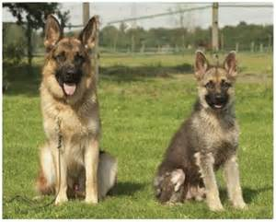
Currently a dwarfism database with all reported affected dogs together with all DNA tested clear and known carriers is being centralised in Holland, the home of dwarfism research. This programme, as a matter of urgency, needs the assistance of not only the Breed Councils but all organisations with an interest in the breed, to ascertain the true extent of the problem which at present we believe is grossly under-estimated. The use of popular sires has been identified as the single most important contributor to the spread of genetic diseases in purebred dogs (Leroy 2011). The Popular Sire syndrome has been known about for a very long time in population genetics, with some dogs having a hugely disproportionate influence on the breed as a whole, passing on both good and bad genes, and this in our opinion has been the main reason for the spread of pituitary dwarfism, and although some restrictions are already in place they don't go far enough in the global market for stud dogs. Restrictions already in place on the number of litters a dam can have will help reduce the spread of hidden undesirable genes.
More serious consideration needs to be given to the consequences with regard to not only simple recessive mutations but also the more difficult complex traits such as

DM and epilepsy, where the use of estimated breeding
values (EBVs) and co-efficients of inbreeding (COIs) need to be used much more than at present - but with a cautionary warning as there is a danger that these methods are currently being seen as able to give some sort of definitive answer to breeding clear dogs when of course they can not. They only help to minimise the probability
of hereditary conditions occurring but don't stop them as some people to seem to think. They are, however, a much better method than the current system of selecting
on phenotype-only that many breeders traditionally adhere to. Numerous organisations advocate ideally that breeding should only be carried out with COI's less than 5% but we have many instances of dwarf dogs being produced by dog's with a COI of 3% and less - therefore in this case only a DNA test can give an accurate picture of a dog's genotype with regards to PD and should be used and managed accordingly.

Unlike DM and epilepsy, we know what the mode of inheritance is with PD and have a DNA test, therefore theoretically it should be relatively easy to reduce its occurrence to negligible levels relatively quickly. New genetic problems will inevitably arise in the future and can quickly spread amongst the population. The question is, when one does arise as pituitary dwarfism has done, do we have the desire to tackle these issues quickly, effectively and openly for the benefit of the German Shepherd Dog breed before it's too late to remove? The ideal way to defeat this condition is to DNA test all breeding pairs for pituitary dwarfism and then mate the identified carriers only to clears - as all geneticists will confirm, there is no need to remove the carriers from the gene pool. Removing the carriers will only deplete the gene pool further with an unnecessary loss of genetic information.

Provided sensible and knowledgeable management of carriers is undertaken, removing the carriers totally from breeding would be a knee jerk reaction which would only further deplete the GSD gene pool. Maybe a KC level 1 DNA control scheme (restricting the use of carriers to mates clear of the gene) is the only answer, but this needs to be discussed by all German Shepherd Dog Organisations. One thing is clear, this issue is not going to go away without intervention, and will only increase with time.

©Stephen P. Webb

For further information on pituitary dwarfism in the German Shepherd Dog see:

http://gsdpituitarydwarfism.weebly.com/

SAARTJE FOUNDATION for Pituitary Dwarfism in Dogs

▬═○▪◘▪○═▬▬═○▪◘▪○═▬▬═○▪◘▪○═▬▬═○▪◘▪○═▬▬═○▪◘▪○═▬▬═○▪◘▪○═▬▬═○▪◘▪○═▬▬═○▪◘▪○═▬

